
Homeopathy Intake and Consent Form

Personal information
Name: | Today’s Date:
Date of birth (yyyy/mm/dd): | Address:
Primary phone: | Other:
E-mail: | Occupation:
Marital Status: | Dependants:
Name of Emergency Contact: | Phone No.:
Name of Family Medical Doctor: | Phone No.:
Other Health Professional(s) Who Follow(s) You:  1)  2)  3) | Phone No.:  1)  2)  3)
Who referred you/how did you hear about me?:

Prioritize your most important health concerns today:
Concern | Onset | Frequency | Severity
1.
2.
3.
4.
5.
What do you do to relax/relieve stress?

What interests/hobbies do you have?

HEALTH HABITS
What physical activity do you participate in, and how often?

Nutrition
How many meals do you generally eat per day?

Do you skip meals?

How many servings of fruit per day? (1 serving: 1 small fruit, ½cup canned/chopped fruit, ¼cup dried fruit)

How many servings of vegetables do you consume each day? (Svg: ½cup raw/cooked, 1cup leafy veg.)

Are you currently on a special diet? Food allergies? Foods you avoid? Vegetarian?

What and how much do you drink on a typical day? (i.e. water, caffeine drinks, soda, etc.)

Recreational Drugs/Alcohol/Tobacco Use:
How much alcohol/tobacco/recreational drugs do you use on a daily and weekly basis?

PERSONAL MEDICAL HISTORY
(Please select all that apply)
Accident, injury to body or head | Lung Disease (Asthma, COPD, etc.)
Alcoholism or Substance Abuse | Nephritis (Kidney or Urine Trouble)
Anemia (Sickle Cell or Other) | Malnutrition, Rickets
Arthritis/Joint Disease | Mental Trouble/ Depression/Anxiety
Blood Clots/Phlebitis | Numbness, Cramps
Cancer (Specify Type: ) | Operations and Anaesthesia
Congenital Disorder | Paralysis (Fits, Convulsions, Polio, Meningitis)
Diabetes | Prostate trouble
Digestive (Ulcerative Colitis, Crohns, Celiac) | Radiation Treatments
Dysentery, Diarrhea, Typhoid, Cholera, Worms, Parasites, Candida | Respiratory (Septic Tonsils, Adenoids, Sinusitis, Bronchitis, Pneumonia, Asthma, Cold, Fever)
Easy Bleeding | Rheumatic Fever
Frequent Sinusitis | Seizures, Epilepsy
Gall Bladder, Spleen Trouble | Serious Injury or Accident
Hay Fever, Allergy | Sexually Transmitted Disease (Chlamydia, Warts, Herpes)
Hearing Loss | Other STD:
Heart Attack, Heart Disease, Heart Failure | Skin (Eczema, Warts, Hives, Pimples, Boils, Ringworm, Fungus, Scabies, Ulcers)
Heart Murmur | Stroke
Headaches (Migraines, etc.) | Thyroid Disease
High Blood Pressure | Tuberculosis (TB)
High Cholesterol | Unconsciousness
History of Infertility | Urinary Difficulties: (Incontinence, Infections, etc.)
Infectious diseases (Measles, Mumps, Rubella, Smallpox, Whooping Cough, Diphtheria) | Vertigo, dizziness
Kidney Infection/ Stones | Violence, assault, rape
Liver Disease, Hepatitis, Jaundice, Malaria, etc. | Vision Problems
Please list any operations/surgical procedures/blood transfusions/major injuries (with approximate age or dates) *include in Human Chemistry Intake Form instead, if requested*:

WOMEN ONLY

Reproductive History

Age at first menstrual period:
First day of most recent menstrual period:
Usual flow – heavy, moderate or light?
Length of period in days:
Number of days between periods:
Do you have (please underline or bold):
- Painful periods, missed periods, spotting between periods, vaginal bleeding, unusual discharge/Infection, recurring vaginal infections
If you have gone through menopause, have you had any post-menopausal bleeding?
Date of last Pap:
History of abnormal Paps?
Number of:
- Pregnancies -
- Live births -
- Abortions -
- Miscarriages -
Have you experienced complications during pregnancy/delivery/other problems?
Have you ever been on contraceptive medication?

MEN ONLY

Do you have:
- Prostate problems
- Testicular cancer
- Vasectomy
- Sexual dysfunction
- Other:

MEDICATIONS
What medications are you taking now? (Include prescription and over-the-counter drugs.)
1)
2)
3)
4)

Are you allergic to or have you had a “bad reaction” to any medications, vaccines or other substances?

If yes, please specify drug(s) and type of reaction:

What vitamins/mineral/herbal supplements are you taking now?

FAMILY MEDICAL HISTORY
Who in your immediate family has any of the following? Place appropriate letter in blank.
(F=father, M=mother, S=sibling, G=grandparent)

_______ Alcoholism or Substance Abuse _______ High Cholesterol
_______ Anemia (Sickle Cell or Other) _______ Kidney Disease
_______ Arthritis _______ Liver Disease
_______ Cancer (Specify Type ______________) _______ Headaches
_______ Lung Disease (Asthma, COPD, etc.) _______ Ulcers
_______ Mental Trouble/ Depression/ Anxiety _______ Hay fever, Allergies
_______ Diabetes _______ Seizure, Epilepsy
_______ Digestive (Ulcerative Colitis, Crohns, etc.) _______ Stroke
_______ Easy Bleeding _______ Suicide
_______ Glaucoma _______ Thyroid Disease
_______ High Blood Pressure _______ Tuberculosis (TB)
_______ Heart Attack, Heart Disease, Heart Failure _______ Other

Pain and Discomfort

Please mark in the figure below the locations of your trouble and write the exact sensation or type of pain you experience at those spots. For example if you have throbbing pain on the right side of your head, please mark as shown:
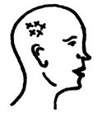
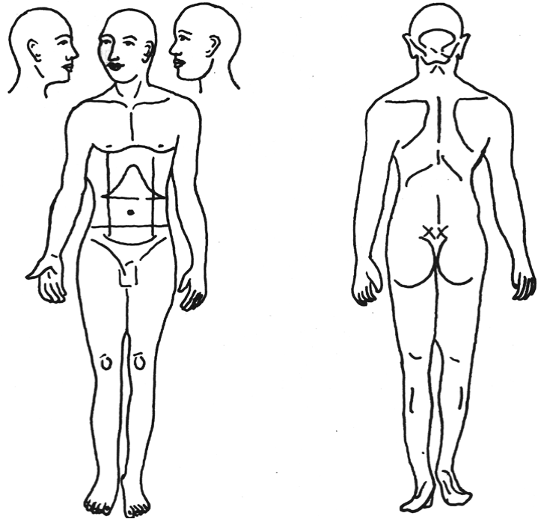

Consent Form for Homeopathic Assessment and Treatment

Patient Name: File No: _______________________________________
Registrant Name: Danielle Durie Registration #: 15653____________________________
- Confidentiality
  - Your Intake Form, a written transcript and my notes during your appointment will be collected and recorded electronically. Your personal and health information will not be used for any other reason than for analyzing your case and I am the only person with access to these records. Only upon your written permission, will I share your case information (verbally or share access to electronic documents) with a colleague or mentor to assist me in providing the best care for you and this would be discussed and agreed upon ahead of time.
  - Your personal and health information must be kept confidential according to confidentiality and privacy requirements as per the Personal Health Information Protection Act (2004) and the Personal Information Protection and Electronic Documents Act (2000). Note that your personal and health information may be disclosed without consent for reasons including to protect another person from serious bodily harm or for certain legal proceedings. Also note that any personal and health information disclosed via e-mail is not guaranteed to remain confidential.

- Homeopathic Principles and Processes
  - Homeopathy is a complete and holistic system of medicine that uses natural remedies to treat disease according to the principle of symptom similarity.
  - The goal of homeopathy is to identify the cause of the disease and find a single (or a series) of remedies to treat the totality of disease. Homeopathy offers gentle, deep acting and long lasting treatments, treats the cause of disease and is a holistic treatment of the whole person including mental and emotional issues, it does not interact with other medicines and is complementary to other healing modalities.
  - A specific outcome cannot be guaranteed and depends on the individual and the Homeopath’s ability to prescribe correct remedies. Risks of homeopathic treatment are minor, including short-lived aggravations. Incorrect dosing may lead to unwanted aggravation and weakening of vitality. It is important to share accurate medical history and any relevant medical information/records. The risks of not undergoing homeopathic treatment may include for example worsening of the disease state or requirement/dependency of conventional medication.
  - The patient’s role is to share openly and honestly and to participate actively in the treatment process. The role and responsibility of the homeopath is to offer an open, accepting space, to listen and provide the best homeopathic care possible while being open and transparent about the treatment process and expectations. During the consultation, you will share your concerns and I will listen and ask questions to get a full picture of your situation. After the consultation, I may prescribe a remedy right away or I may need some time (days) to analyze your case. We will agree on a treatment plan and you will follow up with me to review your reaction to the remedy and to discuss next steps.

- Nature and Safety of Medicines
  - Homeopathic medicines (remedies) are made from substances found in nature. They are diluted to the point where there are no active molecules left and prepared in such a way (dynamization) that enhances the latent healing properties of the substances while minimizing any toxicity. They are inherently safe and work by stimulating the body’s innate healing mechanisms.

- Duration and Frequency of Visits and Treatment Expectations
  - For chronic health issues, initial appointments are 1.5 hours. Follow-up appointments are generally 30 min to 1 hour and once per month for the first few months, and less frequent as the patient improves.
  - For acute health issues, initial appointments are 30 min to 1 hour and follow-ups may be more frequent and closer together, until the acute situation resolves.
  - Some patients improve immediately (especially for acute ailments) while most chronic cases take longer to feel initial improvement and can expect 2-3 years for deeper healing once on the right remedy.

- Fee schedule
  - Refer to my website for the full fee schedule (www.duriehomeopathy.com).
    - Initial 1.5 hour appointment: $225
    - 1 hour follow up: $150
    - 30 min follow up/ acute: $85
  - Individual remedies are $9 and are not included in the consultation fee. You may be asked to pick up remedies at another local Homeopath’s clinic or wait for remedies to be shipped.
  - Online payment is made by credit card after the consultation.

Assessment and Recommended Treatment:
______________________________________________________________________________________________________________________________________________________________________________________________________________________________________________________________________________________________________

Patient Agreement:
My signature acknowledges that I have read and understood the following:
- Homeopathy complements but does not replace conventional medical care and diagnosis. A Homeopath does not make conventional medical diagnoses, and regular appointments with a general practitioner or any specialists I have been seeing are strongly recommended. Any tests and diagnoses of my condition provided by my primary health care provider will be important information for my follow ups.

- I assume full responsibility for my choices about medical care. I understand that I should always consult my MD before cutting down on or discontinuing any prescription medication. I understand that if I forgo standard medical treatment in favor of Homeopathy I assume responsibility for any potential risks.

- I understand that personal information collected here is treated as confidential and private and will not be shared with any other party without my consent, unless ordered to in writing by a judge, or unless required by law (i.e. if a client discloses to a practitioner that he or she is at significant risk of harming him/herself or others).

- I consent to your use of my email address to communicate with me and send occasional news and information. I understand that my email address will never be shared or sold.

Terms and Conditions: Please note that cancellations and rescheduling within 24 hours of your appointment will be subject to full payment.

- I have read and agree to the Terms above.

- I, the undersigned, do hereby acknowledge that I have been informed of and understand the assessment and recommended treatment described above and have discussed to my satisfaction this and any requests for related information with the Homeopath named above. I have been given the opportunity to ask questions about the assessment and recommended treatment and have received answers to such questions. I further acknowledge and confirm that I have been informed of, and understand the procedure(s) with respect to the nature of the procedure, expected benefits, material risks, material side effects and financial cost; the likely consequences of not having the procedure(s), and what alternative course(s) of action are available to me. I understand that I can withdraw my consent at any time. As a result, I do hereby voluntarily provide my informed consent for the recommended treatment specified above.

_____________________________________________________________ [print patient name]

_____________________________________________________________ __________________________
[print name of Legal Guardian/Substitute Decision Maker if applicable] [relationship to patient]

Signature: ___________________________________________ on:______________________
[signature] [yyyy/mm/dd]

